Voxel-wise Intermodal Coupling Analysis of Two or More Modalities using Local Covariance Decomposition

Fengling Hu1,✉, Sarah M. Weinstein1, Erica B. Baller4, Alessandra M. Valcarcel1, Azeez Adebimpe4, Armin Raznahan8, David R. Roalf3, Tim Robert-Fitzgerald1, Virgilio Gonzenbach1, Ruben C. Gur3,5,7, Raquel E. Gur3,5,7, Simon Vandekar9, John A. Detre7, Kristin A. Linn1, Aaron Alexander-Bloch3, Theodore D. Satterthwaite*4, and Russell T. Shinohara*1,2

05 January, 2022

1 Penn Statistics in Imaging and Visualization Endeavor (PennSIVE), Department of Biostatistics, Epidemiology, and Informatics, Perelman School of Medicine, University of Pennsylvania  
2 Center for Biomedical Image Computing and Analytics (CBICA), Perelman School of Medicine  
3 Department of Psychiatry, Perelman School of Medicine, University of Pennsylvania  
4 The Penn Lifespan Informatics and Neuroimaging Center, Department of Psychiatry, Perelman School of Medicine, University of Pennsylvania  
5 Department of Radiology, Perelman School of Medicine, University of Pennsylvania  
6 Philadelphia Veterans Administration Medical Center  
7 Department of Neurology, Perelman School of Medicine, University of Pennsylvania  
8 National Institute of Mental Health, Intramural Research Program, National Institute of Health  
9 Department of Biostatistics, Vanderbilt University

✉ Correspondence: [Fengling Hu <[fengling.hu@pennmedicine.upenn.edu](mailto:fengling.hu@pennmedicine.upenn.edu)>](mailto:fengling.hu@pennmedicine.upenn.edu)

# 1 CRediT author statement

Fengling Hu: Conceptualization, Methodology, Software, Validation, Formal analysis, Investigation, Writing – Original Draft, Writing - Review & Editing, Visualization

TODO

<https://www.elsevier.com/authors/policies-and-guidelines/credit-author-statement>

# 2 Abstract

When individual subjects undergo imaging with multiple modalities, biological information is present not only within each modality, but also between modalities – that is, in how modalities covary at the voxel level. Previous studies have shown that the covariance structures between modalities – called intermodal coupling (IMCo) – can be estimated between two modalities, and that two-modality IMCo reveals otherwise undiscovered patterns in neurodevelopment as well as other processes. However, previous IMCo methods are based on the slopes of local weighted linear regression lines, which are inherently asymmetric and limited to the two-modality setting. Here, we present a PCA-based generalization of IMCo regression which uses local covariance decompositions to define a symmetric, voxel-wise coupling coefficient valid for two or more modalities. We then use this method to study coupling between cerebral blood flow, resting state activations, and functional connectivity in 803 subjects between ages 8 and 23. We demonstrate that coupling is spatially heterogeneous and varies with respect to age and sex over the course of neurodevelopment. As availability of multi-modal data increases, principal component-based IMCo offers a natural approach for summarizing relationships between multiple aspects of brain structure and function. An R package is provided.

# 3 Introduction

There is increased availability of multi-modality neuroimaging data on individual subjects, with each modality containing unique information about brain structure or function [TOCITE]. Such data allow us to explore patterns in individual modalities, as well as how patterns in individual modalities relate to each other. Additionally, multi-modal data allows us to observe the local covariance structure, or intermodal coupling (IMCo), between modalities (Baller et al., 2021; Valcarcel et al., 2018b; Vandekar et al., 2016). This local covariance structure can be interpreted as how modalities relate to one another at the voxel level in individual subjects.

Previous studies have shown that IMCo analysis is complementary to single-modality analysis and unveils otherwise undetectable findings [TOCITE]. For example, in neurodevelopment, IMCo between cortical thickness and sulcal depth has suggested the cortical sheet is generally thinner in sulcal locations than in gyral locations and that this relationship was more spatially heterogeneous than previously described (Vandekar et al., 2016). Additionally, this study showed that the strength of coupling was lower in males compared to females and decreased with age. A separate study exploring IMCo between cerebral blood flow and amplitude of low frequency fluctuations (ALFF) showed that age-related declines in neurovascular coupling occurred most drastically during mid-adolescence and were enriched in the dorsal attention network (Baller et al., 2021). There were also differences in CBF-ALFF coupling between males and females; these differences were enriched in the frontoparietal network. Furthermore, in multiple sclerosis, IMCo has demonstrated use as a data augmentation tool to improve the predictive accuracy of an automated lesion detection model over models using individual modality data alone (Valcarcel et al., 2018a, 2018b).

In these prior studies, each voxel-wise coupling value was defined as the slope of the weighted regression lines fit within a local neighborhood between two modalities. However, because this method of calculating IMCo is based on regression slopes, it does not take into account voxel-level correlation and also suffers from inherent asymmetry, where coupling values depend on the order in which modalities are listed. For example, depending on which modality is the reference modality, a coupling value, $m$, will change to its inverse, $1/m$; this issue is especially problematic for coupling values with very small or very large magnitudes. Thus, this asymmetry necessitates arbitrary, yet influential, decision-making when it comes to analysis and inhibits straight-forward interpretation. Such a measure for IMCo is also limited to only two modalities, so the study of coupling between more than two modalities would require analysis of all pairwise coupling maps. As the number of total modalities increase, this can quickly become overwhelming to interpret.

We propose a novel, principal component analysis (PCA) based method for estimating IMCo that uses local covariance decomposition to define symmetric voxel-wise coupling values valid for two or more modalities. This method reduces complex local covariance structures into a single value. Thus, our approach provides a more natural and interpretable way of describing coupling in settings with two modalities. It also allows for simplified study of overall local covariance structure in settings with more than two modalities. To demonstrate its sensitivity to biologically relevant patterns, we show that PCA-based IMCo uncovers differences in three-modality coupling with respect to age and sex throughout neurodevelopment.

# 4 Methods

## 4.1 Subjects

We included 803 subjects (340 males) from ages 8-23 (mean = 15.6; sd = 3.3) from the Philadelphia Neurodevelopmental Cohort (PNC) (Satterthwaite et al., 2014). Of the 1445 PNC subjects who underwent neuroimaging, we excluded those meeting any of the following criteria: history of psychoactive medication (n = 165), history of inpatient psychiatric hospitalization (n = 51), or history of medical disorders that could impact brain function (n = 166). From the remaining 1113 subjects, we included those who underwent the combination of T1-weighted MRI, arterial spin labeling MRI (ASL), and resting state fMRI (rfMRI) scanning, each of acceptable image quality as determined by automated and manual screening. This resulted in the final set of 803 subjects used for this study.

The Institutional Review Boards of the University of Pennsylvania and the Children’s Hospital of Pennsylvania approved all study procedures. All study subjects gave informed consent; for subjects under the age of 18, parents or guardians provided consent and subjects provided assent. Additional details of the PNC study have been previously described [Gur et al. (2020)](Satterthwaite et al., 2014).

## 4.2 Image acquisition

All PNC imaging was acquired using a single 3T Siemens Tim Trio scanner with a 32-channel head coil. To minimize motion, subjects’ heads were stabilized using one foam pad over each ear and one over the top of the head. Image acquisition procedures have been previously described [Gur et al. (2020)](Satterthwaite et al., 2014).

T1 structural images were used for alignment of all scans into common space. T1 images by 3D-encoded magnetization-prepared, rapid acquisition gradient echo (MPRAGE) T1-weighted sequence with the following settings: $T_{R}$ = 1810 ms; $T_{E}$ = 3.51 ms; FoV = 180 × 240 mm; matrix size = 192 x 256; number of slices = 160; slice thickness = 1 mm; inter-slice gap = 0 mm; resolution = 0.9375 × 0.9375 × 1 mm. Cerebral blood flow (CBF) was estimated from a 3D-encoded spin-echo pseudo-continuous arterial spin labeling (pcASL) sequence with the following settings: $T_{R}$ = 4000 ms; $T_{E}$ = 15 ms; FoV = 220 × 220 mm; matrix size = 96 x 96; number of slices = 20; slice thickness = 5 mm; inter-slice gap = 1 mm; resolution = 2.3 x 2.3 x 6 mm; 80 volumes. Maps of amplitude of low frequency fluctuations (ALFF) and regional homogeneity (ReHo) were estimated from six minutes of task-free functional data from a blood oxygen level-dependent (BOLD-weighted) 2D EPI sequence with the following settings: $T_{R}$ = 3000 ms; $T_{E}$ = 32 ms; FoV = 192 × 192 mm; matrix size = 64 x 64; number of slices = 46; slice thickness = 3 mm; inter-slice gap = 0 mm; resolution = 3 mm isotropic; 124 volumes. Subjects were instructed to stay awake, keep their eyes open and fixated on a displayed fixation cross, and remain still.

## 4.3 Image processing

Image processing of T1 structural images, pcASL scans, and rfMRI scans have been previously described [Gur et al. (2020)](Baller et al., 2021). They are summarized here in brief. T1 structural images were processed using FreeSurfer version 5.3 (Fischl, 2012). pCASL and rfMRI scans were processed using an eXtensible Connectivity Pipeline (XCP) which included tools from FSL and AFNI [Ciric et al. (2018)](Jenkinson et al., 2012)(Cox, 1996).

CBF was quantified from control-label pairs using the following equation:

$$f=\frac{ΔMλRe^{ωR}}{2M_{0}α\left(1−e^{−τR}\right)}$$

,

where f is CBF, $ΔM$ is the difference in signal between control and label acquisitions, $R$ is the longitudinal relaxation rate of blood, $τ$ is the labeling time, $ω$ is the post-labeling delay, $α$ is the labeling efficiency, $λ$ is the blood-tissue-water partition coefficient, and $M_{0}$ is approximated by the control image intensity. We set $α=0.85$, $λ=0.9g/mL$, $τ=1.6s$, $ω=1.2s$. Finally, CBF images were co-registered to T1 structural images.

For rfMRI processing, the XCP pipeline included: 1) field inhomogeneity correction with FSL FUGUE, 2) removal of initial rfMRI volumes, 3) alignment of volumes within the time series to a selected reference volume using FSL MCFLIRT, 4) interpolation of intensity outliers with AFNI 3dDespike, 5) demeaning and removal of linear or quadratic trends, and 6) co-registration of rfMRI data to T1 structural images using boundary-based registration. Images were then denoised using a 36-parameter confound regression model. Finally, blood-oxygen-level-dependent (BOLD) weighted time series as well as artifactual model time series were filtered using a first-order Butterworth filter with a passband between 0.01 and 0.08 Hertz.

Voxel-wise ALFF was defined as the sum of frequency bins between 0.01 and 0.08 Hertz using a Fourier transform of the time-domain signal (Yang et al., 2007). Voxel-wise ReHo was defined as Kendall’s coefficient of concordance computed over the rfMRI time series in each voxel’s 26-voxel local neighborhood (Zang et al., 2004). This voxel-wise map was then smoothed to improve signal-to-noise ratio.

## 4.4 Estimation of intermodal coupling

For each subject, we calculated voxel-wise IMCo between CBF, ALFF, and ReHo modalities. Even though ALFF and ReHo are calculated from the same rfMRI modality, we refer to them as separate modalities because they measure different information – ALFF is a measure of resting state activations and ReHo is a measure of local connectivity.

The full IMCo estimation pipeline is summarized in Figure 4.1. First, we applied a grey matter mask to each of the three modalities. Then, within each masked modality, we globally scaled intensities to a mean of 0 and a variance of 1. This scaling is necessary because eigendecomposition is later performed on local covariance matrices; if modalities were defined on drastically different scales, decomposition outputs would reflect differences in baseline overall variance between modalities rather than local covariance structures. Next, for each voxel, we extracted local neighborhoods from each of the three modalities and weighted voxels within these local neighborhoods proportional to a Gaussian kernel over their Euclidean distances from the central voxel – in our study, we used FWHM = 3, which corresponds to 7x7x7 voxel (14x14x14 mm) local neighborhoods and a standard deviation of 1.62 mm for the Gaussian kernel. Then, we calculated the 3x3 weighted covariance matrix between the neighborhoods, performed eigendecomposition on them, and extracted the proportion of variance explained by the first eigenvalue. Once all the voxel-wise proportional first eigenvalues were extracted, we scaled these values such that the minimum was 0 and maximum was 1 and then performed a logit transformation so extreme values of coupling would be emphasized. This resulted in our voxel-level coupling value, where a large value means that the voxel’s local covariance matrix could be well-summarized in a single dimension.



Figure 4.1: Step-by-step diagram of IMCo estimation pipeline.

For reference, in the three-modality setting, coupling values of -2, 0, and 2 correspond to the first eigenvector explaining 41%, 67%, and 92% of the total variance in that local neighborhood, respectively. In the two-modality setting, coupling values of -2, 0, and 2 correspond to the first eigenvector explaining 56%, 75%, and 94% of the total variance in that local neighborhood, respectively.

## 4.5 Voxel-wise statistical analysis

We created descriptive coupling maps by taking the means and variances across all 803 subjects at each voxel location in volumetric space. We then projected these mean and variance maps to the FreeSurfer sphere using PySurfer for visualization of spatial heterogeneity and cortical patterns (Waskom et al., 2020).

To investigate biological relevance of PCA-based IMCo, we used linear regression at each voxel to explore whether coupling was associated with age or sex effects. In all linear regressions, we controlled intra-scanner motion for both ASL and rfMRI scans. To control for multiple comparisons in these voxel-level tests, we controlled the false discovery rate at 5% (Benjamini and Hochberg, 1995). Then, we created binary thresholded masks indicating which tests remained significant post-correction for both age and sex. For this and following analyses, we performed identical modeling of each of the three modalities individually to explore whether the presence of age and sex effects on modality intensities corresponded to the presence of age and sex effects on coupling values (Supplementary Materials).

To visualize the extent of voxels where coupling was associated with age and sex, we counted the proportion of voxels with statistically significant age or sex effects in each of the Yeo 7 functional networks as well as in Automated Anatomical Labeling (AAL) atlas subcortical regions of interest (Thomas Yeo et al., 2011; Tzourio-Mazoyer et al., 2002). We also projected the thresholded p-value maps to the FreeSurfer sphere for visualization and further analyses.

## 4.6 Spin testing

For each of the age and sex thresholded p-value maps projected to the FreeSurfer sphere, we then tested whether the proportion of significant voxels in each functional network was enriched when compared to the proportion of significant voxels overall. Because there is an underlying spatial distribution of significant voxels, we used the spin test (Alexander-Bloch et al., 2018). Briefly, the spin test is a conservative, permutation-based test that rotates the FreeSurfer sphere randomly to create an underlying null distribution that preserves spatial patterns. In our study, we estimated the null distribution over 2,000 permutations – for each permutation, we recorded the Jaccard similarity index between the thresholded p-value map and each of the Yeo 7 networks. Finally, for each network, we calculated the p-value as the proportion of null Jaccard similarity indices equal to or greater than the observed Jaccard similarity index.

## 4.7 Code availibility

An R package for calculating PCA-based IMCo images is available at: <https://github.com/hufengling/IMCo_PCA>. All code for analysis is available at: <https://github.com/hufengling/IMCo_analyses>. All software and packages used for pre-processing, IMCo calculation, or analysis are cited in the bibliography.

# 5 Results

## 5.1 Cortical coupling voxel-wise descriptive maps

We calculated voxel-wise mean and variance maps of coupling values to characterize spatial patterns in CBF-ALFF-ReHo coupling and visualized these on the FreeSurfer sphere. Throughout the cortical surface, all voxels showed strong coupling, and voxels with stronger average coupling also had higher variance between subjects. The average voxel-wise mean coupling value was 0.99 (sd = 0.37; range from 0.27 to 3.30). The average voxel-wise variance was 0.91 (sd = 0.20; range from 0.45 to 2.64).

Visual comparison of voxel-wise descriptive maps with the Desikan-Killiany cortical atlas (Desikan et al., 2006) suggests that coupling is especially strong in the following regions, bilaterally: superior frontal gyrus, paracentral gyrus, caudal anterior cingulate, posterior cingulate, isthmus cingulate, pericalcarine, lateral occipital, and insula (Figure 5.1). These regions also tended to show higher variance.

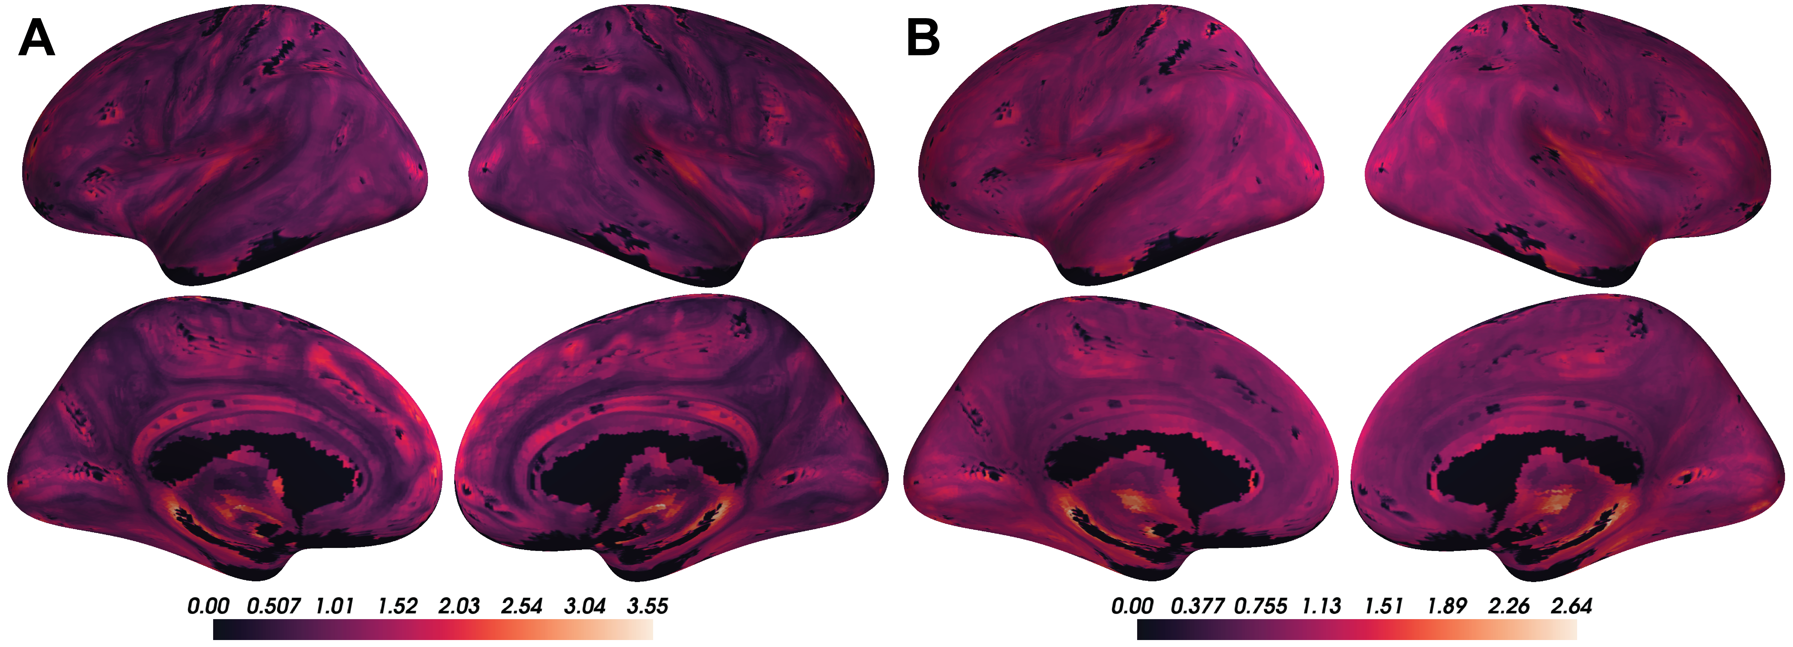

Figure 5.1: A) Voxel-wise means across subjects of cortical coupling coefficients between CBF, ALFF, and ReHo. Larger values indicate stronger coupling. B) Voxel-wise variances across subjects of cortical coupling coefficients between CBF, ALFF, and ReHo.

Comparing to the Yeo 7 functional networks, areas of strong coupling are observed primarily in the default and frontoparietal networks. Small portions of the visual network as well as other networks also show strong coupling, though those patterns were less apparent.

These voxel-wise descriptive maps of coupling showed unique information to descriptive maps of each of the individual modalities (Supplementary Figures 10.1, 10.2, and 10.3).

## 5.2 CBF-ALFF-ReHo coupling evolves with age throughout gray matter structures

Linear associations between strength of coupling and age were present in subcortical structures and cortical networks (Figure 5.2; corrected p < 0.05). In subcortical structures, age-related changes in CBF-ALFF-ReHo coupling occurred primarily in the caudate and pallidum, though such changes were also observed in sizable proportions of the hippocampus, putamen, and thalamus.

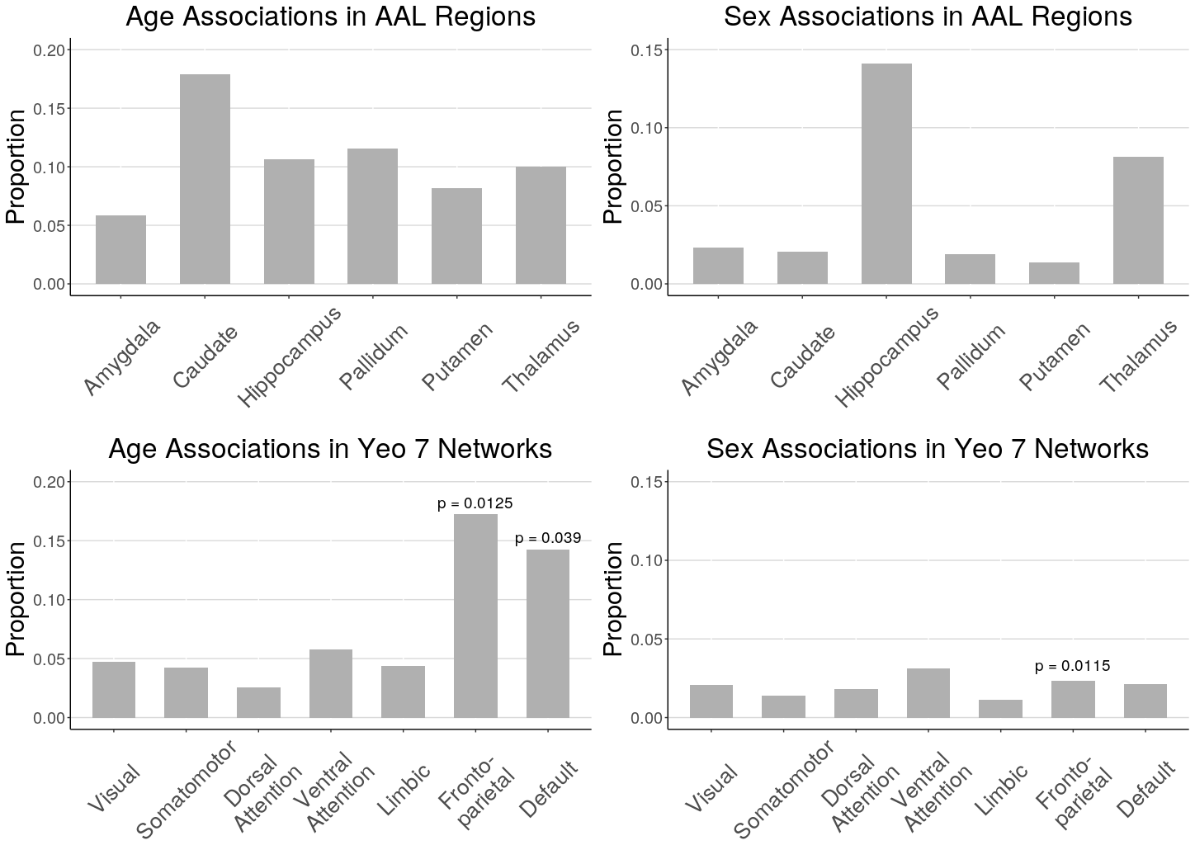

Figure 5.2: Proportion of voxels in AAL subcortical regions and Yeo 7 cortical networks that showed significant age and sex effects when race and in-scanner motion were corrected included as covariates (FDR corrected p < 0.05). Spin test was performed for Yeo 7 networks and significant p-values are reported (p < 0.05).

In cortical networks, coupling and age associations were rare in all networks except the frontoparietal and default networks (Figure 5.3). These two networks were also the networks in which the average strength of coupling across subjects appeared to be highest (Figure 5.1). Spin testing between functional networks and age-related changes in coupling showed enrichment of coupling and age associations in the frontoparietal (p = 0.013) and default networks (p = 0.039).

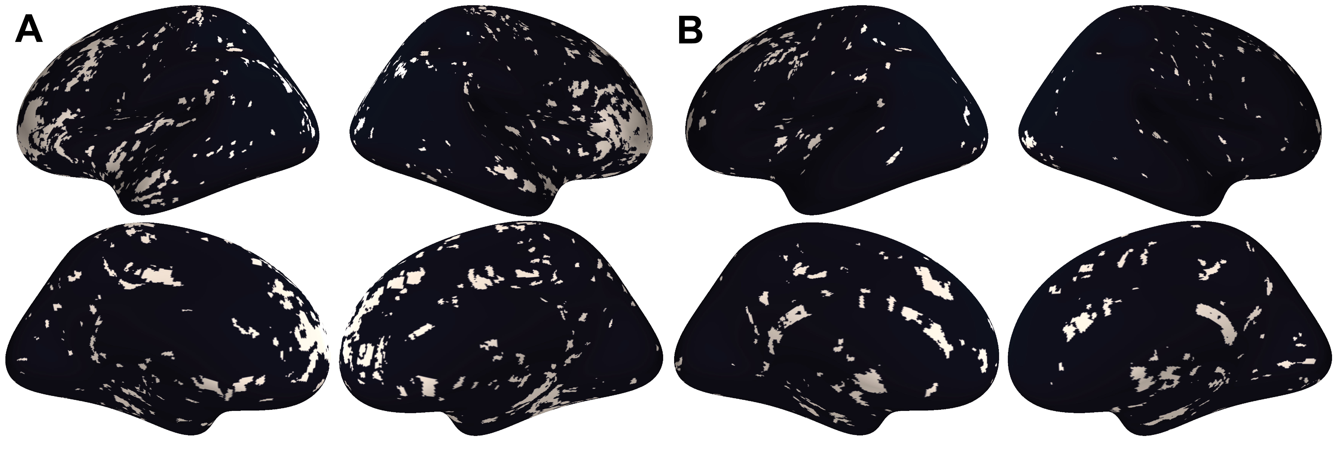

Figure 5.3: A) Thresholded maps of voxels with significant coupling associations with age after FDR correction at 0.05. B) Thresholded maps of voxels with significant coupling associations with sex after FDR correction at 0.05.

## 5.3 CBF-ALFF-ReHo coupling varies between males and females, primarily in subcortical regions

Associations between CBF-ALFF-ReHo coupling and sex were present primarily in the hippocampus and thalamus (Figure 5.2; corrected p < 0.05). Coupling was rare in other subcortical structures and all functional networks – only 1% to 3% of voxels in these regions showed coupling and sex associations (Figure 5.3).

Spin testing between functional networks and sex-related changes in coupling revealed enrichment of coupling and sex associations in the frontoparietal network (p = 0.012), despite the small proportion of the frontoparietal network that exhibited coupling associations with sex.

# 6 Discussion

As growing emphasis is placed on the acquisition of multi-modal data, new methodologies are necessary to enable these analyses. In 2016, Vandekar et al. introduced a method based on local regression slopes to study IMCo relationships at the single voxel level and showed it could reveal patterns between cortical thickness and sulcal depth that had been undiscovered by studies conducted on regions of interest or across the entire cortex (Vandekar et al., 2016). Since then, this method for studying local coupling has continued to enable discoveries (Baller et al., 2021). However, despite its strengths, because this method relies on estimating regression slopes between modalities, it is inherently limited to the two-modality setting, cannot take correlation between modalities into account, and is asymmetric.

In this manuscript, we introduce a generalized approach to estimating IMCo that can be applied to two or more modalities, can be interpreted as a direct summary of local covariance matrices, and is symmetric. This method can be used with any combination of volumetric images to produce single-subject, voxel-resolution coupling images which can then be analyzed using standard techniques. We applied this method to show significant coupling between cerebral blood flow, resting state activations, and local connectivity throughout the brain. We then used voxel-level analyses to characterize how coupling varies in neurodevelopment.

## 6.1 Coupling of blood flow, resting state activation, and connectivity vary with age and sex

We found that CBF-ALFF-ReHo coupling was spatially heterogeneous and varied with age and sex in neurodevelopment in both subcortical structures and cortical networks. These findings, which uncover otherwise undetectable intermodal interactions, are unique to those from individual modality analyses. We noticed that regions with high CBF-ALFF-ReHo coupling across subjects also tended to have high variance in coupling. This suggests these regions may be biologically interesting in the context of CBF-ALFF-ReHo coupling. However, it is uncertain whether this signal is driven by local changes across all subjects, specific subject-level phenotypes, or something else entirely. In future studies, we will investigate such regions further to explain this heterogeneity.

Spin testing showed that the high proportion of coupling-age associations in the frontoparietal and default networks were enriched when compared to the cortex overall. This suggests that in neurodevelopment, there is change in not only vascular organization, resting state activation, and connectivity individually, but also in the strength of interaction between these features. These findings are consistent with and fortify the literature demonstrating the importance of frontoparietal and default networks as regions for change in neurodevelopment [TOCITE]. In subcortical structures, high proportions of coupling associations with age seen in the caudate, pallidum, hippocampus, and thalamus suggest that modulation of vascular, resting state activation, and connectivity coupling may be necessary in the development of movement, memory, and fundamental brain activities.

High proportions of coupling associations with sex in the hippocampus and thalamus suggest that male-female differences in memory and fundamental brain activities between males and females could be explained in part by the strength of vascular organization, resting state activation, and connectivity coupling. The rarity of coupling-sex associations throughout the cortex suggests that this coupling may not play a role in explaining sex-based differences in higher-order processing.

Interestingly, despite low coupling-sex signal in the frontoparietal network, spin testing showed enrichment of coupling associations with sex in this network. Since spin testing is a spatial permutation test that uses the sex-coupling association thresholded p-value map to generate data under the null, this is likely due to a combination of overall rare such associations in the cortex and the particular spatial distribution of these associations within the frontoparietal network. This finding highlights potential shortcomings of using the spin test for enrichment analysis. Additionally, statistical analysis of enrichment in subcortical structures is not yet possible. More methods development is needed in this area.

## 6.2 Limitations

PCA-based IMCo is designed to summarize a complex local covariance structure as one value to allow for easy analysis and data reduction. While this property is a main strength of the method, it leads to outputs that can be challenging to interpret, and these outputs cannot fully characterize the intricacies of coupling. This is especially true in settings with more than two modalities, as the covariance structure becomes even more complex and biological interpretation of coupling between many modalities can be non-intuitive.

The symmetric nature of PCA-based IMCo is conducive to more consistent interpretation when compared to slope-based IMCo. However, while slope is an intuitive measure that can be interpreted as capturing the effect size of a relationship, the generalizable nature of our PCA-based coupling value makes it challenging to interpret biologically. Instead, it is most accurately interpreted in statistical terms – as a measure of the proportion of variance explained by the first eigenvector, or as a measure of how well the local covariance structure can be summarized by the first eigenvector. Here, we chose to interpret neighborhoods whose covariance structures could be well-summarized as ones that are strongly coupled.

This interpretation of PCA-based coupling highlights that in two-modality settings it cannot describe biological directionality of coupling – whether local increases in one modality lead, on average, to increases or decreases in the other modality. In more than two modalities, pairwise directionality is not described. Instead, it can only describe the strength of the coupling relationship. However, this can also be seen as an improvement over slope-based IMCo – with PCA-based IMCo, larger values uniformly correspond to stronger coupling, while with slope-based IMCo, more positive or more negative values both correspond to stronger coupling.

Finally, though PCA-based coupling does not require specification of an arbitrary reference modality to calculate coupling values, it is still subject to other run-time choices, such as FWHM value or application of masks.

## 6.3 Future directions

In this study, we applied PCA-based IMCo to study coupling between features derived from pcASL and rfMRI modalities. In the future, this method can be applied to any study in which interactions between multiple modalities are of interest. For example, Shokri-Kojori et al. showed that correspondence between cerebral glucose metabolism and fluctuations in blood oxygenation not only differed between brain networks in healthy patients but was also sensitive to differences related to acute or chronic alcohol use (Shokri-Kojori et al., 2019). However, these correspondence analyses were performed regionally or globally – voxel-wise IMCo analyses could reveal further insights.

In the context of neurodegenerative disorders, it is well-known that Alzheimer’s disease is characterized by changes in structural and functional MRI as well as in amyloid-tau positron emission tomography (PET) (Frisoni et al., 2010; Rowley et al., 2020; Sperling, 2011). Numerous studies have been done to characterize Alzheimer’s-related changes in these individual modalities as well as on interactions between these modalities (Buckner et al., 2005; Hasani et al., 2021; Ren et al., 2020; Wales and Leung, 2021). In this setting, PCA-based IMCo could provide voxel-level resolution in pairwise comparisons as well as in all three modalities together. This could be useful as a data reduction tool to simplify complex covariance structures for descriptive analyses as well as a data augmentation tool for predictive efforts.

# 7 Conclusion

PCA-based IMCo offers a generalized approach for describing coupling between two modalities, as well as a novel perspective for summarizing the overall covariance structure between more than two modalities. Here, we applied this method to the analysis of coupling between cerebral blood flow, resting state activations, and local connectivity maps. This analysis revealed patterns in neurodevelopment with respect to age and sex that were unique to those present in any individual modality. As multi-modal data becomes more common, we hope that PCA-based IMCo will serve as a tool for capturing complex intermodal relationships and allow for additional descriptive analyses, improved prediction efforts, and novel methodological advances, among others.

# 8 Acknowledgements

This study was supported by grants from the National Institute of Mental Health (R01MH112847 to TDS and RTS; R01MH120482 and R01MH113550 to TDS; R01 MH123550-01 to RTS; R01MH107235 to RCG; 2T32MH019112-29A1 to EBB; R01MH120174, R01MH119185, and R56AG066656 to DRR). The PNC data used was funded by NIMH RC2 grants (MH089983 and MH089924 to REG).

# 9 References

Alexander-Bloch, A.F., Shou, H., Liu, S., Satterthwaite, T.D., Glahn, D.C., Shinohara, R.T., Vandekar, S.N., Raznahan, A., 2018. On testing for spatial correspondence between maps of human brain structure and function. NeuroImage 178, 540–551. <https://doi.org/10.1016/j.neuroimage.2018.05.070>

Allaire, J., Xie, Y., McPherson, J., Luraschi, J., Ushey, K., Atkins, A., Wickham, H., Cheng, J., Chang, W., Iannone, R., 2021. [Rmarkdown: Dynamic documents for r](https://CRAN.R-project.org/package=rmarkdown).

Avants, B.B., 2020. ANTsR: ANTs in r: Quantification tools for biomedical images.

Baller, E.B., Valcarcel, A.M., Adebimpe, A., Alexander-Bloch, A., Cui, Z., Gur, R.C., Gur, R.E., Larsen, B.L., Linn, K.A., O’NADonnell, C.M., Pines, A.R., Raznahan, A., Roalf, D.R., Sydnor, V.J., Tapera, T.M., Tisdall, M.D., Vandekar, S., Xia, C.H., Detre, J.A., Shinohara, R.T., Satterthwait, T.D., 2021. Developmental coupling of cerebral blood flow and fMRI fluctuations in youth. bioRxiv. <https://doi.org/10.1101/2021.07.28.454179>

Benjamini, Y., Hochberg, Y., 1995. [Controlling the False Discovery Rate: A Practical and Powerful Approach to Multiple Testing](https://www.jstor.org/stable/2346101). Journal of the Royal Statistical Society. Series B (Methodological) 57, 289–300.

Buckner, R.L., Snyder, A.Z., Shannon, B.J., LaRossa, G., Sachs, R., Fotenos, A.F., Sheline, Y.I., Klunk, W.E., Mathis, C.A., Morris, J.C., Mintun, M.A., 2005. Molecular, Structural, and Functional Characterization of Alzheimer’s Disease: Evidence for a Relationship between Default Activity, Amyloid, and Memory. J. Neurosci. 25, 7709–7717. <https://doi.org/10.1523/JNEUROSCI.2177-05.2005>

Ciric, R., Rosen, A.F., Erus, G., Cook, P.A., Bassett, D.S., Davatzikos, C., Wolf, D.H., Satterthwaite, T.D., 2018. Mitigating head motion artefact in functional connectivity MRI. Nat Protoc 13, 2801–2826. <https://doi.org/10.1038/s41596-018-0065-y>

Cox, R.W., 1996. AFNI: Software for analysis and visualization of functional magnetic resonance neuroimages. Computers and Biomedical research 29, 162–173.

Desikan, R.S., S’egonne, F., Fischl, B., Quinn, B.T., Dickerson, B.C., Blacker, D., Buckner, R.L., Dale, A.M., Maguire, R.P., Hyman, B.T., Albert, M.S., Killiany, R.J., 2006. An automated labeling system for subdividing the human cerebral cortex on MRI scans into gyral based regions of interest. Neuroimage 31, 968–980. <https://doi.org/10.1016/j.neuroimage.2006.01.021>

Fischl, B., 2012. FreeSurfer. Neuroimage 62, 774–781.

Frisoni, G.B., Fox, N.C., Jack, C.R., Scheltens, P., Thompson, P.M., 2010. The clinical use of structural MRI in Alzheimer disease. Nat Rev Neurol 6, 67–77. <https://doi.org/10.1038/nrneurol.2009.215>

Gur, R.C., Butler, E.R., Moore, T.M., Rosen, A.F.G., Ruparel, K., Satterthwaite, T.D., Roalf, D.R., Gennatas, E.D., Bilker, W.B., Shinohara, R.T., Port, A., Elliott, M.A., Verma, R., Davatzikos, C., Wolf, D.H., Detre, J.A., Gur, R.E., 2020. Structural and Functional Brain Parameters Related to Cognitive Performance Across Development: Replication and Extension of the Parieto-Frontal Integration Theory in a Single Sample. Cereb Cortex 31, 1444–1463. <https://doi.org/10.1093/cercor/bhaa282>

Hasani, S.A., Mayeli, M., Salehi, M.A., Barzegar Parizi, R., 2021. A Systematic Review of the Association between Amyloid-β and τ Pathology with Functional Connectivity Alterations in the Alzheimer Dementia Spectrum Utilizing PET Scan and rsfMRI. DEE 11, 78–90. <https://doi.org/10.1159/000516164>

Jenkinson, M., Beckmann, C.F., Behrens, T.E., Woolrich, M.W., Smith, S.M., 2012. FSL. Neuroimage 62, 782–790.

Kandel, B.M., Cook, P.A., Tustison, N.J., Muschelli, J., 2020. ANTsRCore: Core software infrastructure for ’ANTsR’.

Müller, K., 2020. [Here: A simpler way to find your files](https://CRAN.R-project.org/package=here).

Muschelli, J., 2021a. Extrantsr: Extra functions to build on the ’ANTsR’ package.

Muschelli, J., 2021b. Neurobase: ’Neuroconductor’ base package with helper functions for ’nifti’ objects.

Muschelli, J., Sweeney, E., Lindquist, M., Crainiceanu, C., 2015. Fslr: Connecting the FSL software with r. The R Journal 7, 163–175.

R Core Team, 2021. [R: A language and environment for statistical computing](https://www.R-project.org/). R Foundation for Statistical Computing, Vienna, Austria.

Ren, H., Zhu, J., Su, X., Chen, S., Zeng, S., Lan, X., Zou, L.-Y., Sughrue, M.E., Guo, Y., 2020. Application of Structural and Functional Connectome Mismatch for Classification and Individualized Therapy in Alzheimer Disease. Frontiers in Public Health 8, 720. <https://doi.org/10.3389/fpubh.2020.584430>

Ren, K., 2021. [Rlist: A toolbox for non-tabular data manipulation](https://CRAN.R-project.org/package=rlist).

Rowley, P.A., Samsonov, A.A., Betthauser, T.J., Pirasteh, A., Johnson, S.C., Eisenmenger, L.B., 2020. Amyloid and Tau PET Imaging of Alzheimer Disease and Other Neurodegenerative Conditions. Seminars in Ultrasound, CT and MRI, Positron Emission Tomography (PET) and Single Photon Emission ComputedTomography (SPECT) Imaging of the Brain 41, 572–583. <https://doi.org/10.1053/j.sult.2020.08.011>

Satterthwaite, T.D., Elliott, M.A., Ruparel, K., Loughead, J., Prabhakaran, K., Calkins, M.E., Hopson, R., Jackson, C., Keefe, J., Riley, M., Mensh, F.D., Sleiman, P., Verma, R., Davatzikos, C., Hakonarson, H., Gur, R.C., Gur, R.E., 2014. Neuroimaging of the Philadelphia Neurodevelopmental Cohort. NeuroImage 86, 544–553. <https://doi.org/10.1016/j.neuroimage.2013.07.064>

Schäfer, T., 2021. [Freesurferformats: Read and write ’FreeSurfer’ neuroimaging file formats](https://CRAN.R-project.org/package=freesurferformats).

Shokri-Kojori, E., Tomasi, D., Alipanahi, B., Wiers, C.E., Wang, G.-J., Volkow, N.D., 2019. Correspondence between cerebral glucose metabolism and BOLD reveals relative power and cost in human brain. Nat Commun 10, 690. <https://doi.org/10.1038/s41467-019-08546-x>

Sperling, R., 2011. The potential of functional MRI as a biomarker in early Alzheimer’s disease. Neurobiol Aging 32, S37–S43. <https://doi.org/10.1016/j.neurobiolaging.2011.09.009>

Thomas Yeo, B.T., Krienen, F.M., Sepulcre, J., Sabuncu, M.R., Lashkari, D., Hollinshead, M., Roffman, J.L., Smoller, J.W., Zöllei, L., Polimeni, J.R., Fischl, B., Liu, H., Buckner, R.L., 2011. The organization of the human cerebral cortex estimated by intrinsic functional connectivity. J Neurophysiol 106, 1125–1165. <https://doi.org/10.1152/jn.00338.2011>

Tzourio-Mazoyer, N., Landeau, B., Papathanassiou, D., Crivello, F., Etard, O., Delcroix, N., Mazoyer, B., Joliot, M., 2002. Automated anatomical labeling of activations in SPM using a macroscopic anatomical parcellation of the MNI MRI single-subject brain. Neuroimage 15, 273–289. <https://doi.org/10.1006/nimg.2001.0978>

Valcarcel, A.M., Linn, K.A., Khalid, F., Vandekar, S.N., Tauhid, S., Satterthwaite, T.D., Muschelli, J., Martin, M.L., Bakshi, R., Shinohara, R.T., 2018a. A dual modeling approach to automatic segmentation of cerebral T2 hyperintensities and T1 black holes in multiple sclerosis. NeuroImage: Clinical 20, 1211–1221. <https://doi.org/10.1016/j.nicl.2018.10.013>

Valcarcel, A.M., Linn, K.A., Vandekar, S.N., Satterthwaite, T.D., Muschelli, J., Calabresi, P.A., Pham, D.L., Martin, M.L., Shinohara, R.T., 2018b. MIMoSA: An Automated Method for Intermodal Segmentation Analysis of Multiple Sclerosis Brain Lesions. J Neuroimaging 28, 389–398. <https://doi.org/10.1111/jon.12506>

Vandekar, S.N., Shinohara, R.T., Raznahan, A., Hopson, R.D., Roalf, D.R., Ruparel, K., Gur, R.C., Gur, R.E., Satterthwaite, T.D., 2016. Subject-level Measurement of Local Cortical Coupling. Neuroimage 133, 88–97. <https://doi.org/10.1016/j.neuroimage.2016.03.002>

Wales, R.M., Leung, H.-C., 2021. The Effects of Amyloid and Tau on Functional Network Connectivity in Older Populations. Brain Connectivity 11, 599–612. <https://doi.org/10.1089/brain.2020.0902>

Waskom, M., Gramfort, A., Burns, S., Luessi, M., Larson, E., 2020. [PySurfer](https://pysurfer.github.io/index.html).

Wickham, H., 2019. [Stringr: Simple, consistent wrappers for common string operations](https://CRAN.R-project.org/package=stringr).

Wickham, H., Averick, M., Bryan, J., Chang, W., McGowan, L.D., François, R., Grolemund, G., Hayes, A., Henry, L., Hester, J., Kuhn, M., Pedersen, T.L., Miller, E., Bache, S.M., Müller, K., Ooms, J., Robinson, D., Seidel, D.P., Spinu, V., Takahashi, K., Vaughan, D., Wilke, C., Woo, K., Yutani, H., 2019. Welcome to the tidyverse. Journal of Open Source Software 4, 1686. <https://doi.org/10.21105/joss.01686>

Xie, Y., 2021a. [Bookdown: Authoring books and technical documents with r markdown](https://CRAN.R-project.org/package=bookdown).

Xie, Y., 2021b. [Knitr: A general-purpose package for dynamic report generation in r](https://yihui.org/knitr/).

Xie, Y., 2016. [Bookdown: Authoring books and technical documents with R markdown](https://bookdown.org/yihui/bookdown). Chapman; Hall/CRC, Boca Raton, Florida.

Yang, H., Long, X.-Y., Yang, Y., Yan, H., Zhu, C.-Z., Zhou, X.-P., Zang, Y.-F., Gong, Q.-Y., 2007. Amplitude of low frequency fluctuation within visual areas revealed by resting-state functional MRI. Neuroimage 36, 144–152. <https://doi.org/10.1016/j.neuroimage.2007.01.054>

Zang, Y., Jiang, T., Lu, Y., He, Y., Tian, L., 2004. Regional homogeneity approach to fMRI data analysis. Neuroimage 22, 394–400. <https://doi.org/10.1016/j.neuroimage.2003.12.030>

# 10 Supplementary Materials

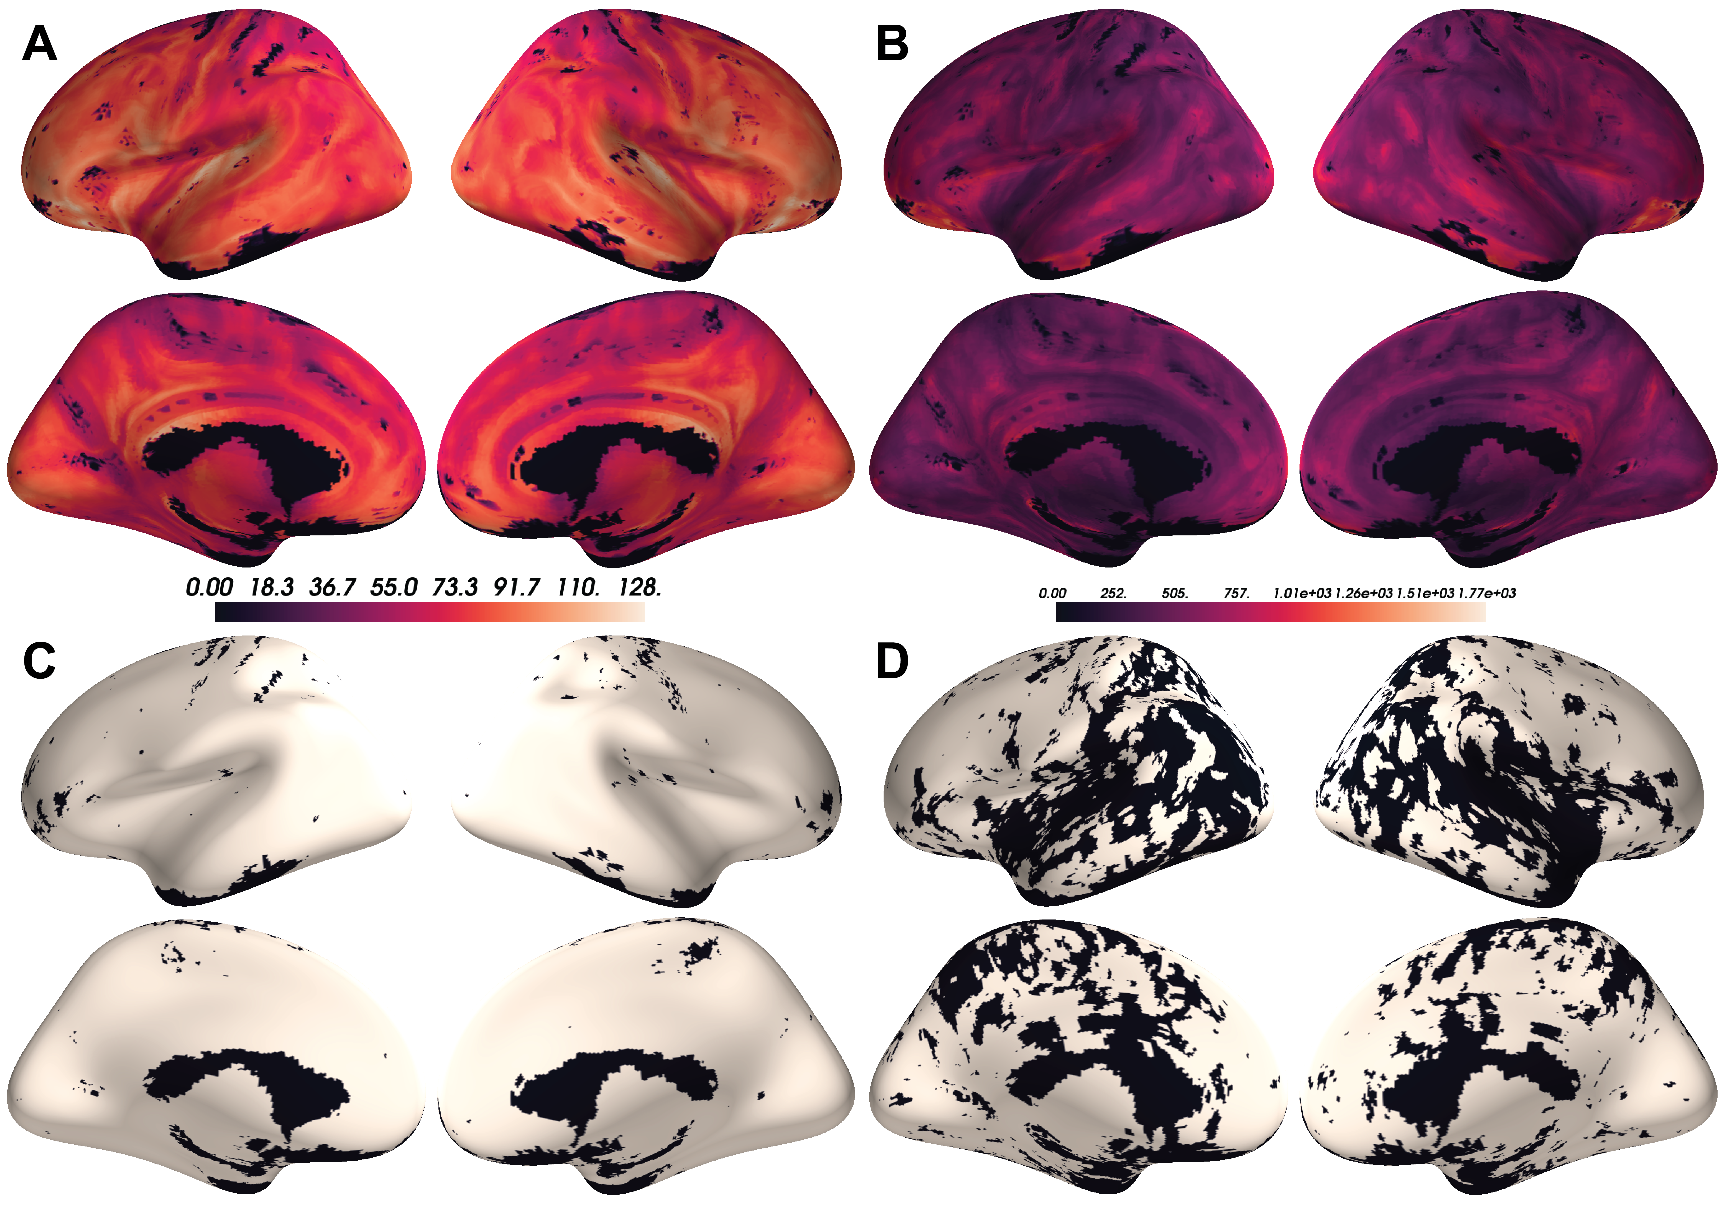

Figure 10.1: A) Voxel-wise means across subjects of cortical CBF. B) Voxel-wise variances across subjects of cortical CBF. C) Thresholded maps of voxels with significant CBF associations with age after FDR correction at 0.05. D) Thresholded maps of voxels with significant CBF associations with sex after FDR correction at 0.05.

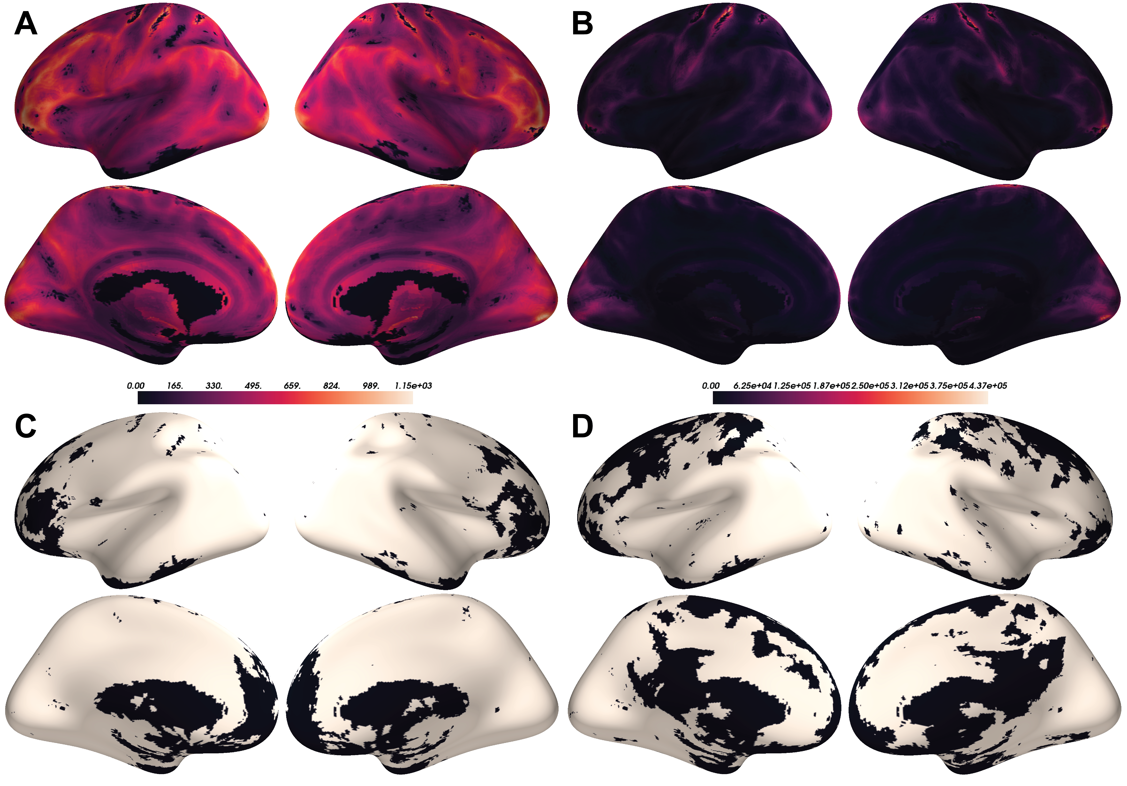

Figure 10.2: A) Voxel-wise means across subjects of cortical ALFF. B) Voxel-wise variances across subjects of cortical ALFF. C) Thresholded maps of voxels with significant ALFF associations with age after FDR correction at 0.05. D) Thresholded maps of voxels with significant ALFF associations with sex after FDR correction at 0.05.

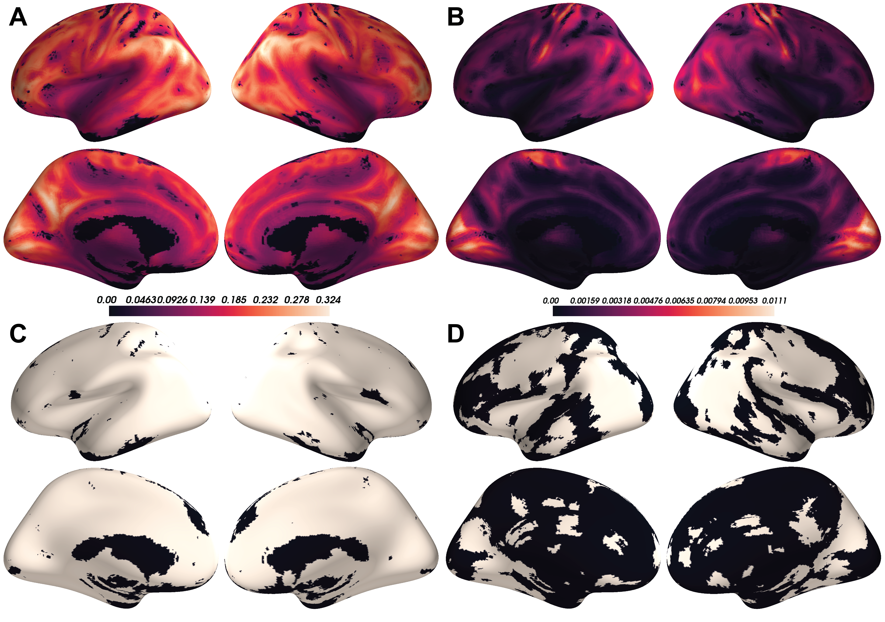

Figure 10.3: A) Voxel-wise means across subjects of cortical ReHo. B) Voxel-wise variances across subjects of cortical ReHo. C) Thresholded maps of voxels with significant ReHo associations with age after FDR correction at 0.05. D) Thresholded maps of voxels with significant ReHo associations with sex after FDR correction at 0.05.